Lab Manual for TYBSc CS 2020-2021 USCS607:Ethical Hacking

Roll No :18043 Date:20/02/2021

**Practical 3**

**Aim:** **Use WireShark sniffer to capture network traffic and analyze.**

Step 1: Install and open WireShark.

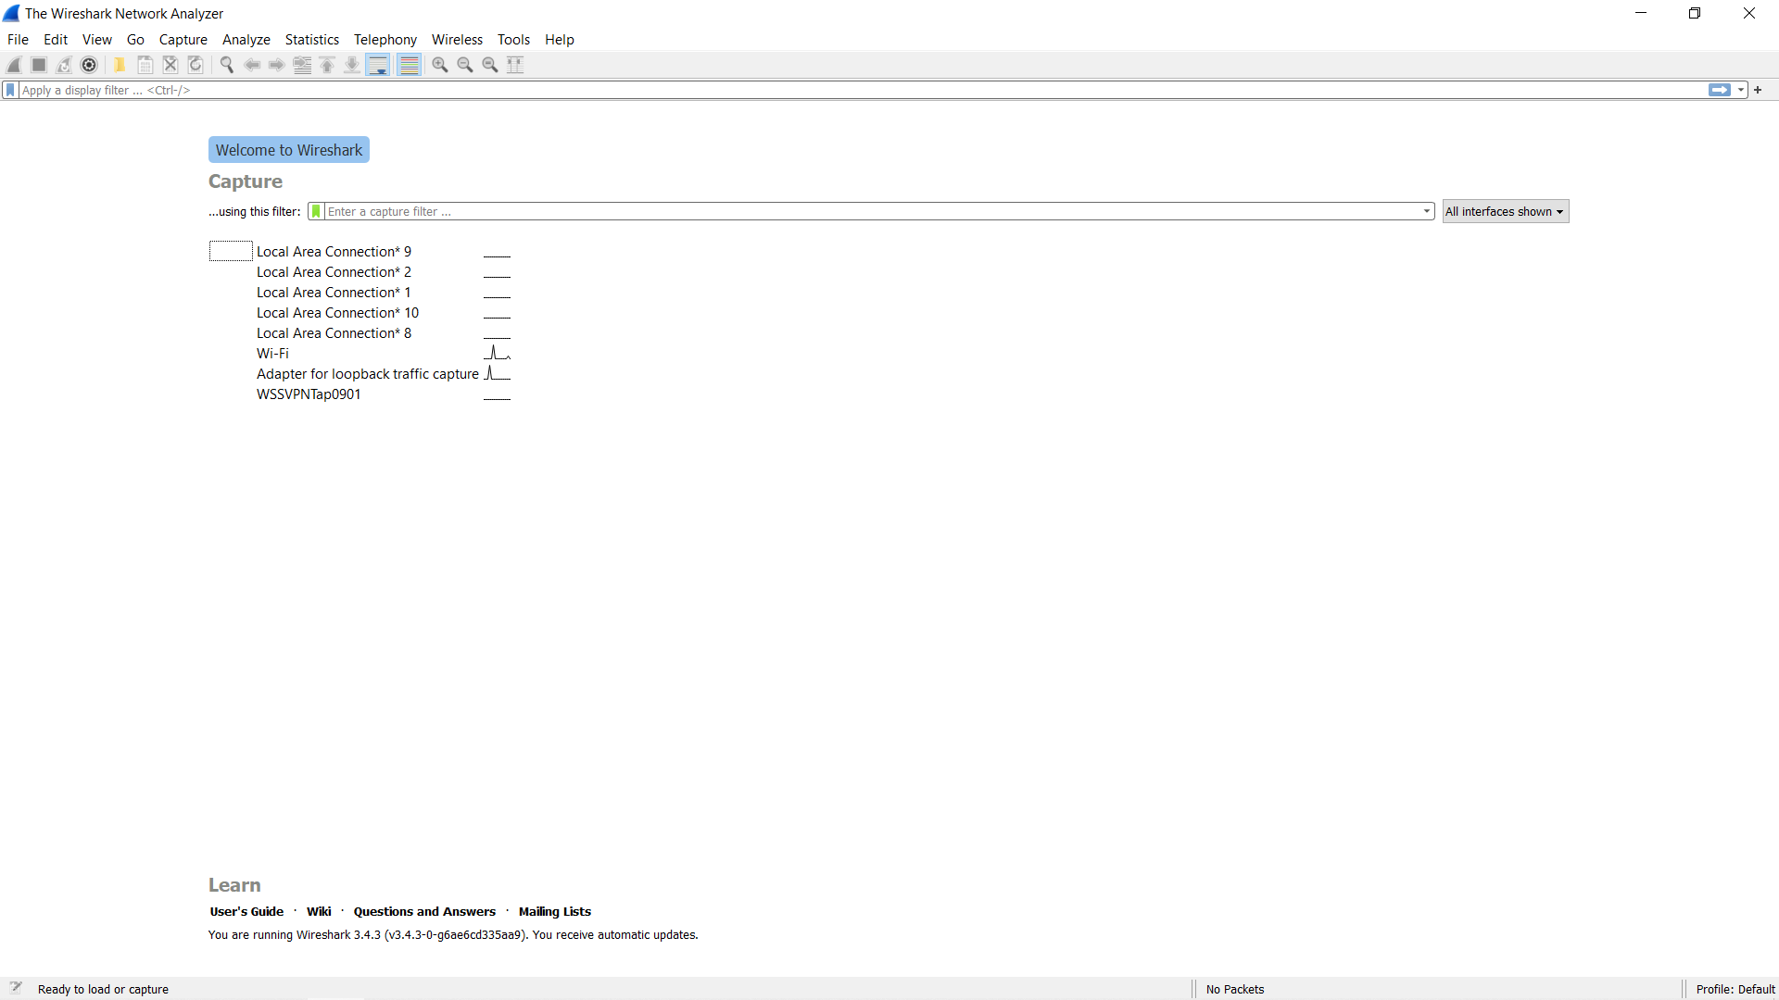

Step 2 : And in the capture tab select your connection. Mine is Wi-Fi.

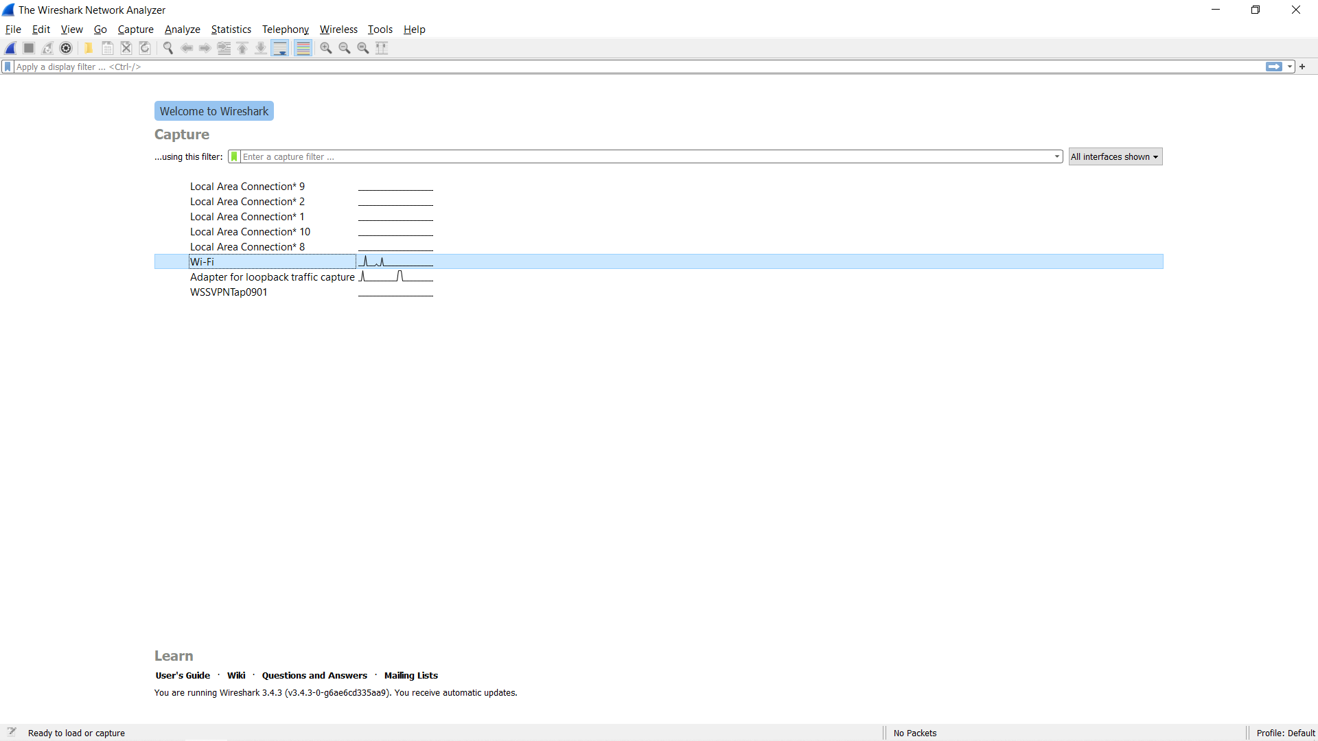

Step 3 : The source, Destination and protocols of the packets in the LAN network are displayed.

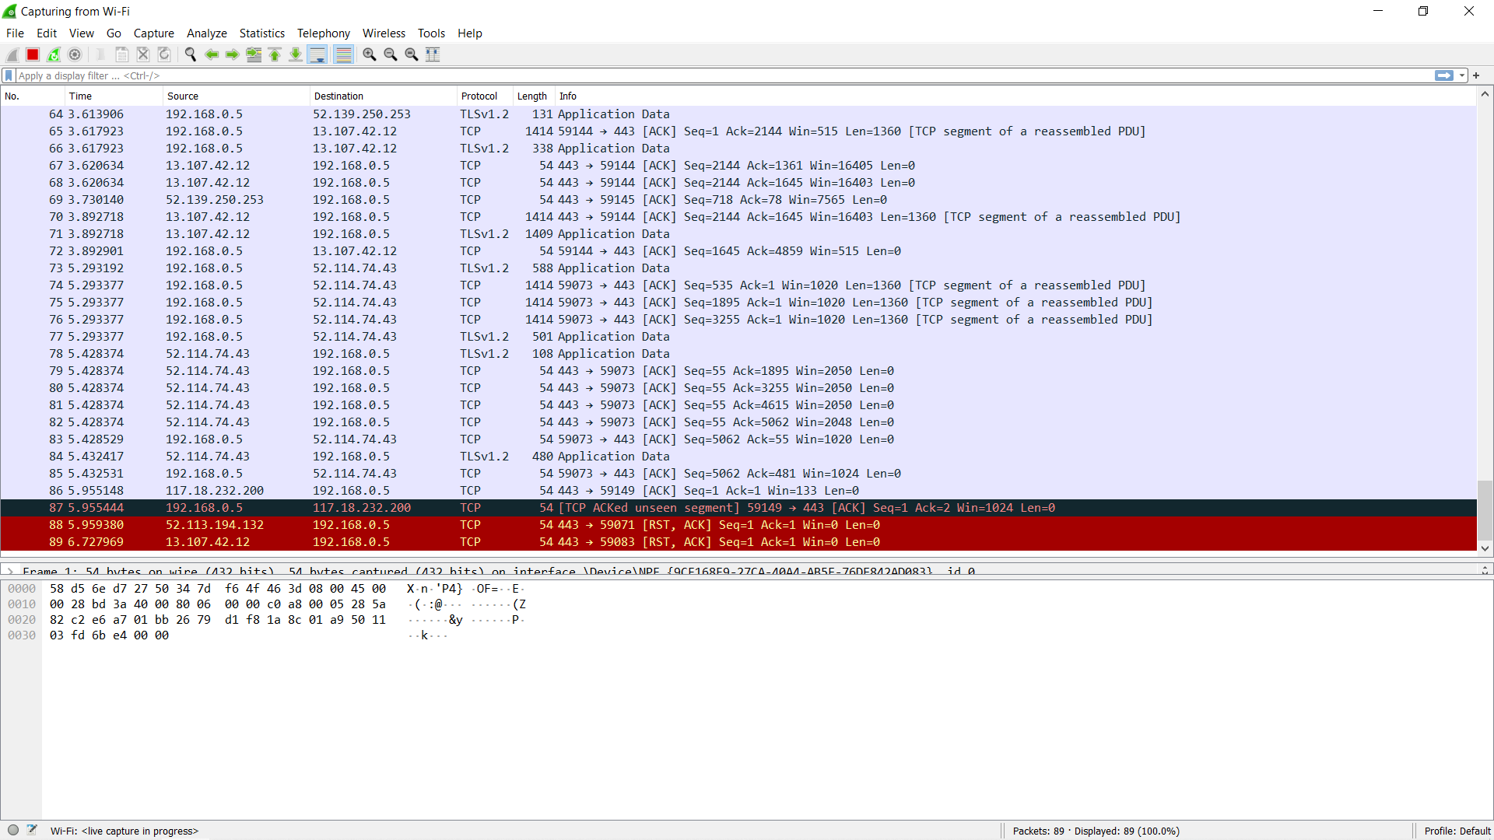

Step 4 : Open a website in a new window

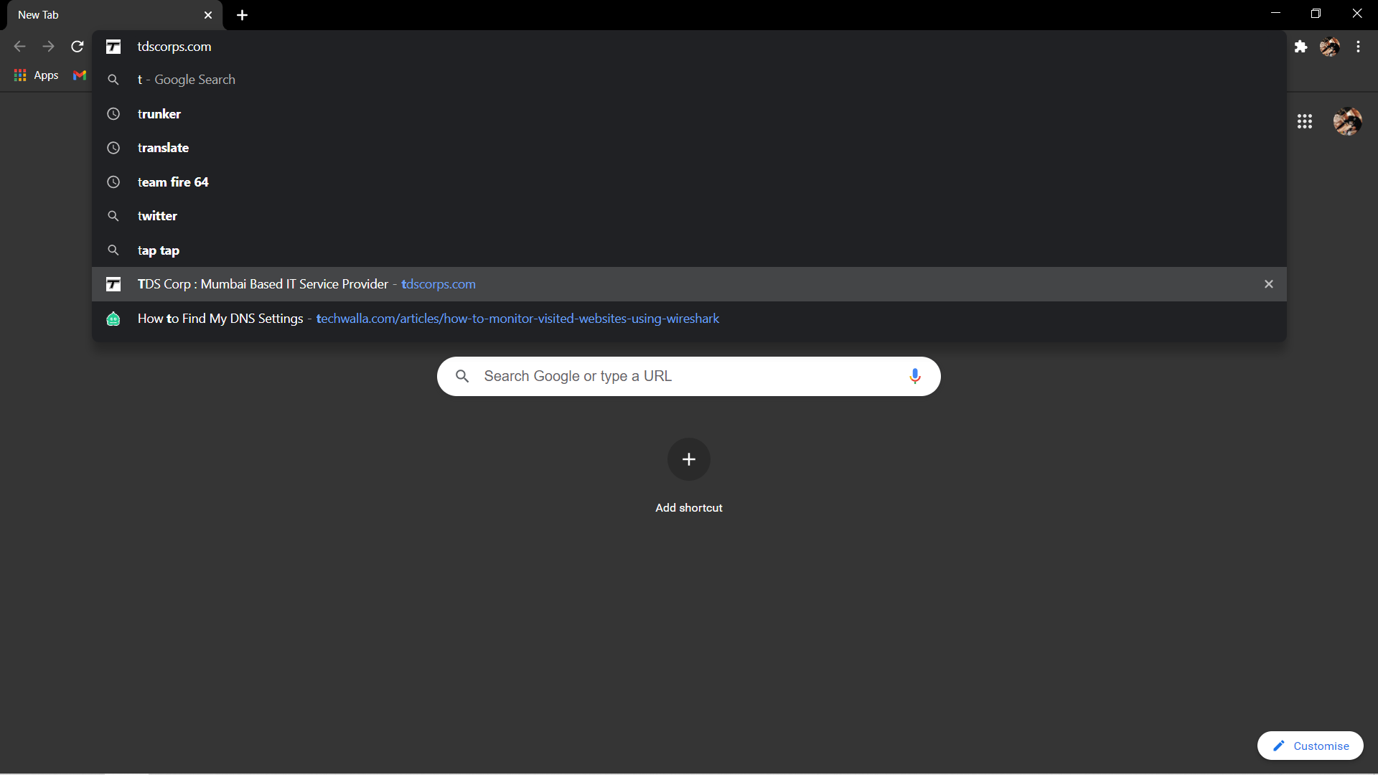

Step 5 : And fill a form. Register if needed.

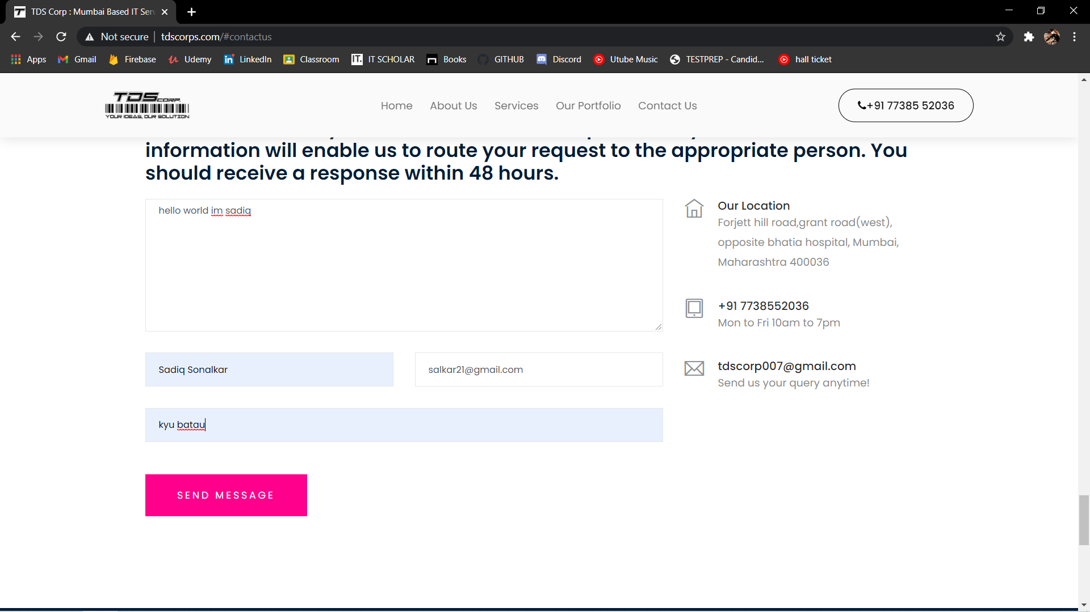

Step 6 : The wireshark tool will keep recording the packets.



Step 7 : Now stop the tool to stop recording.

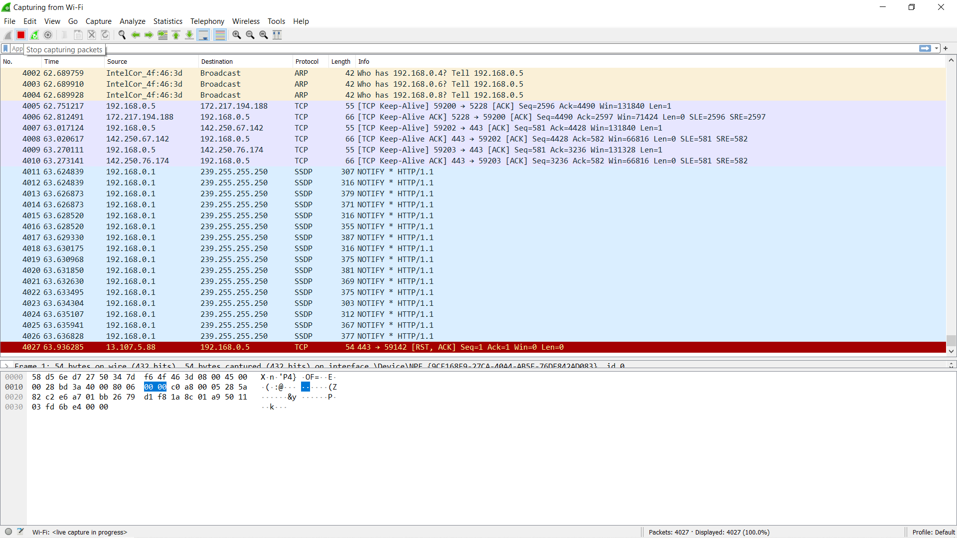

Step 8 : Select filter as http to make the search easier and click Enter.

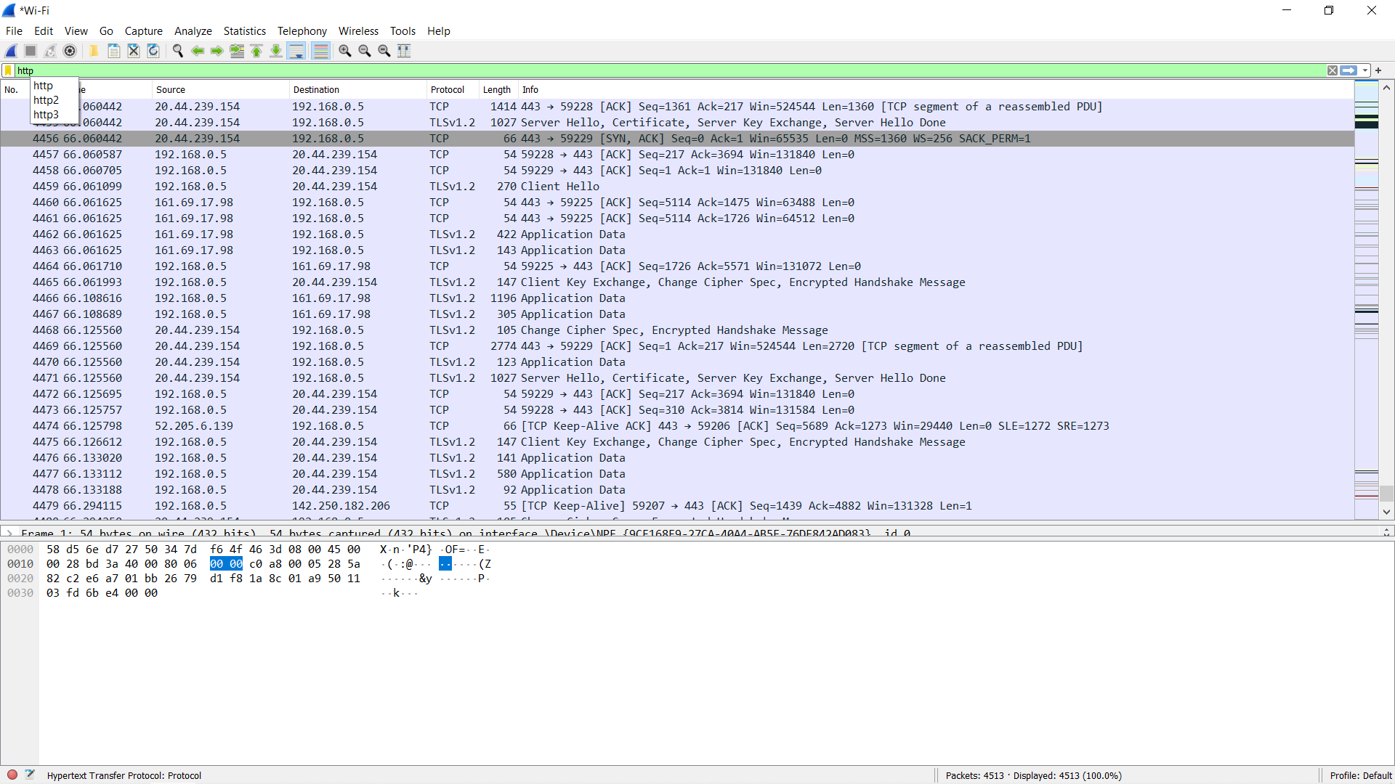

Step 9: Find the post methods for username and passwords.

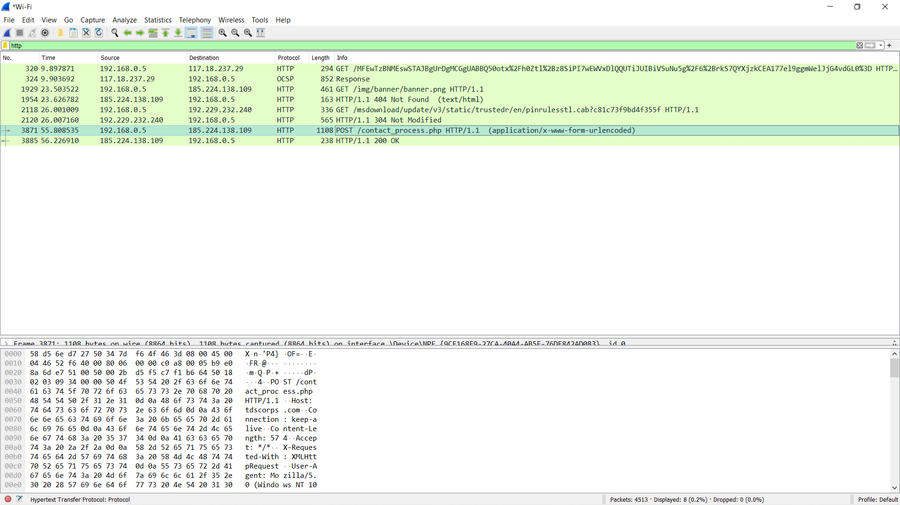

Step 10 : Double click on the post method. And you will get the details.

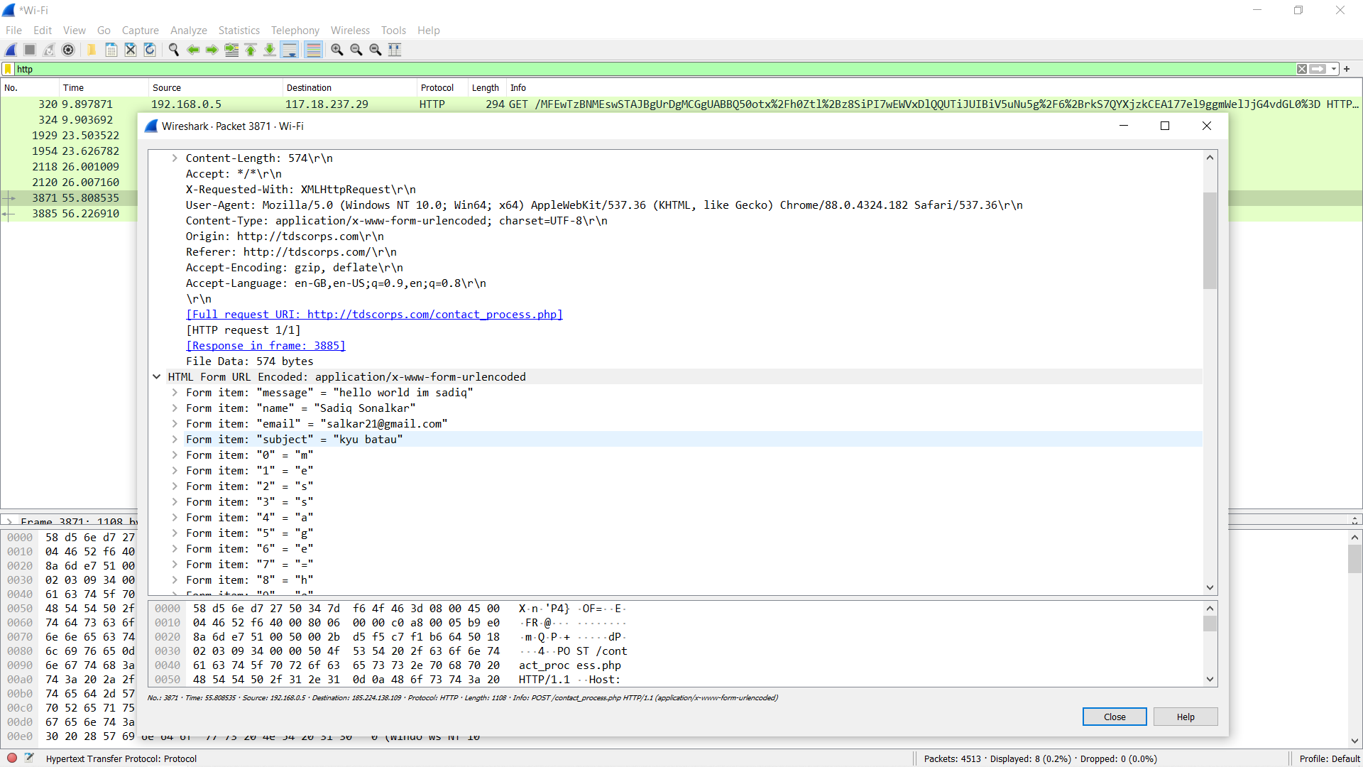

Step 11 : Right Click on the POST method >> Follow >> TCP stream.

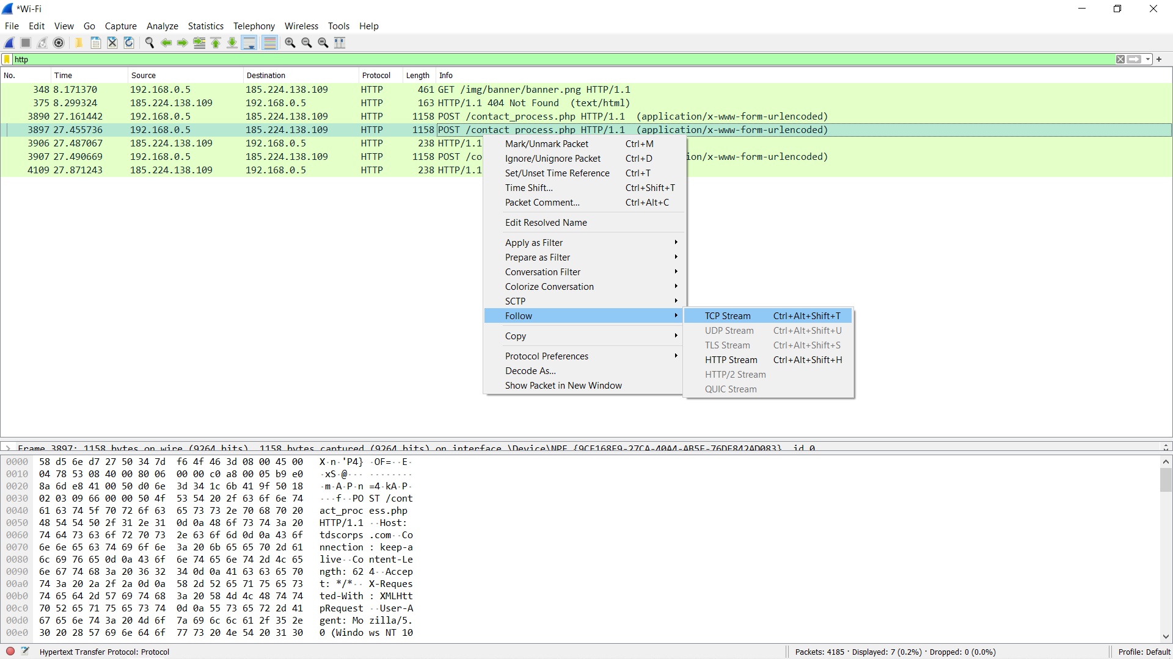

Step 12 : You will get the Details by follow TCP streams method.

